AOHMassage Program 2023-5

AOHMassage Foundation Program includes
F1: Subtle Body includes FREE 1 CE Ethics Values & 5-Elements Class, F2: Touch,
F3: Reflexology
All available either in-person or online anytime CE Broker (FL)
All Classes approved by FL Board of Health and NCBTMB

All Foundation Classes are prerequisites for the
Hands-On In-Person Classes which include Signature AOHMassage Organic Oil
AOHMassage 1: Front of the Body & AOHMassage 2: Back of the Body

AOHMassage Hands-On Week-Long Intensive includes all of the above classes In-Person. 34 CE’s SPECIAL PRICING
F1,F2,F3 may be completed online, webinar, in-person or an
Overview of AOHMassage may be completed before the Hands-On Class.
**A Massage with Alvina or approved therapist is recommended.
Also available 2 CE Ethical Wisdom Class in-person, webinar or anytime.

AOHMassage Weekend includes
a review (Overview) of F1, F2,F3 Classes, optional Ethical Wisdom Class, and 2-days of AOHMassage Practicum SPECIAL PRICING

Please join long-time Massage Teacher Alvina Quatrano for the
AOHMassage Hands-On Massage Classes!!! Check Links for Dates!!!
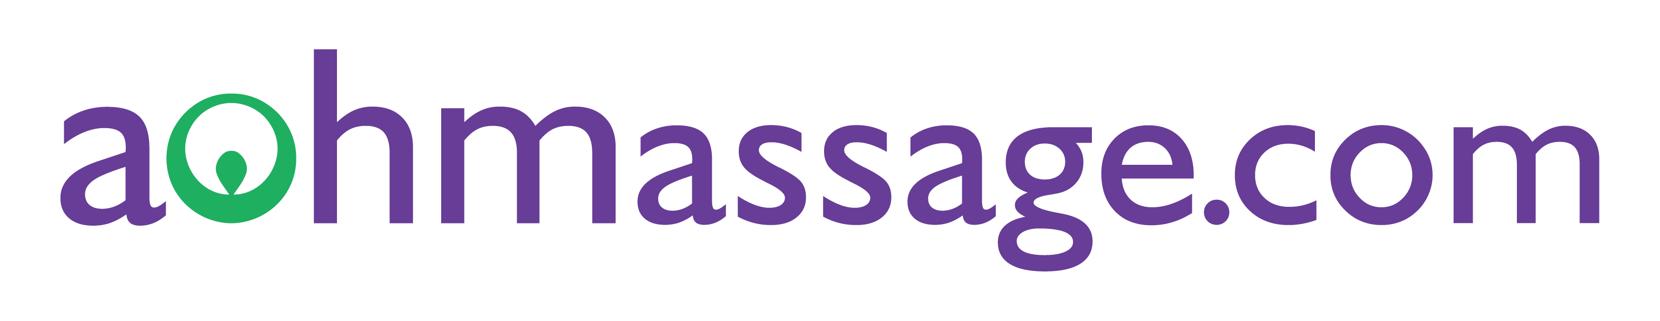
Alvina Quatrano, Licensed Massage Therapist
MA50896 FL Provider 50-9777, NCBTMB Provider 451544-11
732-266-5276 | alvinaq@aohmassage.com | 3323 Olympic Drive #721, Naples, FL 34105

